November 20, 2017

Dear Valued Supplier,
Thank you for your continued working relationship with Advanced Energy.
We would like to take this opportunity to inform you that as of November 30, 2017, Advanced Energy will be updating the purchase order processing entity to AES Global Holdings PTE Ltd. (“AES”). Orders will be issued by and suppliers will be paid from AES, however, there will be NO change to the physical ship-to location.
Please see examples below of how the “Bill To” and “Ship To” addresses will appear on purchase orders issued after November 30, 2017, and update your records accordingly:
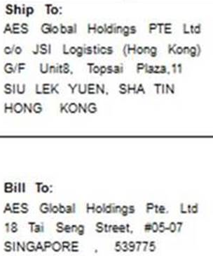

For suppliers receiving payment by check or American Express Credit Card, AES may transition the payment method to wire transfer on January 1, 2018. Please provide the appropriate accounts receivables contact to your AE Commodity Manager for follow up.
Should you have any questions about these changes, please contact your Commodity Manager for support.

Sincerely,
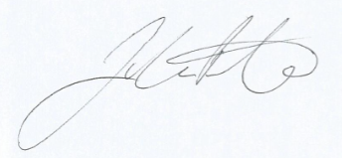
John Prater
Director, Global Supply Chain
Advanced Energy Industries, Inc.

